Selenium Installation and
Troubleshooting Assignment

Names | Sudipa Deb | Enrollment no. | 12023002001226
Campus | IEM (NEWTOWN)

Part B — Technical Investigation Questions
Q1. What is Selenium, and which types of applications is it designed to automate? State two suitable and two unsuitable use cases.
Answer: Selenium is an open-source browser automation framework used to control web browsers through WebDriver. It is designed mainly for testing and automating web applications in supported browsers. Suitable use cases: (1) automated functional/regression testing of a web application, and (2) cross-browser UI testing. Unsuitable use cases: (1) automating native desktop applications that are not exposed through a browser, and (2) testing non-web systems such as an operating-system GUI directly.
Q2. Differentiate Selenium WebDriver, Selenium IDE, and Selenium Grid.
Answer: Selenium WebDriver is the programming API used to control browsers and perform browser automation from code. Selenium IDE is a browser extension that records and replays user actions with little or no coding. Selenium Grid is used to run WebDriver tests remotely and in parallel across multiple machines, browsers, or operating systems.
Q3. Explain the roles of the test script, Selenium client library, browser driver, browser, and WebDriver protocol during one command such as driver.get().
Answer: The test script contains the command, for example driver.get(url). The Selenium client library translates the Python call into a WebDriver command. The WebDriver protocol defines how that command is communicated to the browser-specific driver. The browser driver receives the command and controls the actual browser. The browser then navigates to the requested URL and returns the result/status through the driver and protocol back to the Selenium client and script.
Q4. Why is a virtual environment recommended? What problem can occur when packages are installed globally?
Answer: A virtual environment isolates a project's Python packages from the system Python installation and from other projects. This makes dependencies easier to reproduce and avoids version conflicts. Global installation can cause one project to upgrade or downgrade a package needed by another project, leading to import errors, incompatible dependencies, or different behavior between computers.
Q5. What is Selenium Manager? How has it changed driver setup in recent Selenium versions?
Answer: Selenium Manager is Selenium's automated driver and browser management tool. In recent Selenium versions, Selenium bindings can invoke Selenium Manager automatically when a driver is needed, so users normally do not have to manually download a matching driver or put its path into the code. It can discover the browser, obtain a suitable driver, and manage driver information/cache automatically. Manual configuration can still be relevant in restricted or customized environments.
Q6. Differentiate driver.find_element() and driver.find_elements(). What is returned when no element matches?
Answer: driver.find_element() returns the first matching WebElement. If no matching element is found, it raises NoSuchElementException. driver.find_elements() returns a list of all matching WebElements. If no elements match, it returns an empty list rather than raising NoSuchElementException.
Q7. Compare ID, name, class name, CSS selector, and XPath locators. Which locator strategy would you prefer for stable tests, and why?
Answer: ID targets an element's id and is usually concise and stable when the application provides a stable ID. Name targets the name attribute and can be useful for form controls. Class name targets a single class name and is useful when that class is stable, but it may be shared by many elements. CSS selector can combine IDs, classes, attributes, and relationships and is often concise and readable. XPath can express complex relationships and conditions, but long XPath expressions can become fragile when the DOM changes. For stable tests, I would prefer a unique, stable ID when available; otherwise a short, stable CSS selector or another meaningful attribute. The key reason is that locators should depend on stable application attributes rather than presentation details or deeply nested DOM structure.
Q8. Differentiate implicit wait, explicit wait, and time.sleep(). Give one appropriate use case for each.
Answer: An implicit wait is a driver-level timeout applied when locating elements; it is useful when many elements may take a short, variable time to appear. An explicit wait waits for a specific condition, such as an element becoming visible or clickable; it is appropriate for dynamic pages where a particular event must occur before continuing. time.sleep() pauses for a fixed duration regardless of page state; it is mainly useful for very simple demonstrations or situations where a fixed delay is genuinely required. Explicit waits are generally preferable to arbitrary sleeps for reliable tests.
Q9. Why should driver.quit() normally be placed in a finally block or teardown method? How is it different from driver.close()?
Answer: driver.quit() should normally be placed in a finally block or test teardown so the browser and WebDriver resources are cleaned up even if the test fails or an exception occurs. driver.close() closes only the current browser window or tab. driver.quit() ends the WebDriver session and closes all windows/tabs associated with that session, so it is normally the correct method for final cleanup.
Q10. What causes StaleElementReferenceException? Describe two robust ways to handle it without hiding a genuine application defect.
Answer: StaleElementReferenceException occurs when a WebElement object stored by the script is no longer attached to the current DOM. This commonly happens after the page is refreshed, an element is replaced or re-rendered, or navigation changes the document. Two robust approaches are: (1) locate the element again immediately before interacting with it, preferably using a stable locator and an explicit wait; and (2) when the page is expected to re-render, wait for the old element to become stale and then wait for the replacement element before continuing. A limited retry may be used for a known transient DOM update, but the retry should be bounded and should not catch every exception or ignore persistent failures, because that could hide a real application defect.
Q11. What is headless browser execution? Identify two benefits and two limitations.
Answer: Headless execution runs the browser without displaying its normal graphical window. Benefits: (1) it can run efficiently on servers and CI/CD systems without a desktop environment, and (2) it generally uses fewer graphical resources and is convenient for automated test pipelines. Limitations: (1) rendering, viewport size, downloads, permissions, or timing can sometimes behave differently from normal headed mode, and (2) debugging is harder because the browser UI is not visible; screenshots, logs, and page source are therefore especially useful.
Q12. Explain how browser and driver version mismatch can affect a Selenium session. Is this still relevant when Selenium Manager is used? Justify.
Answer: The browser driver acts as the bridge between Selenium and the browser, so an incompatible driver can prevent a session from starting or cause commands to fail. Selenium Manager reduces this problem by automatically discovering the browser and obtaining a compatible driver when needed. However, version mismatch is still relevant: Selenium Manager can fail to obtain the correct driver because of network restrictions, proxy/firewall problems, PATH conflicts, cached or manually supplied drivers, or an unusual browser installation. Therefore, the browser version and driver actually being used should still be checked when diagnosing a failure.
Q13. Why can a script work on one computer but fail on another? Discuss at least four environment-related reasons.
Answer: A Selenium script can behave differently because the environments are not identical. Common reasons include: (1) different Python or Selenium versions; (2) different browser versions or a driver mismatch; (3) different operating systems, browser binary locations, or system architecture; (4) different PATH settings or Python/IDE interpreters, causing packages or drivers to be found differently; (5) different proxy, firewall, or internet access settings affecting driver downloads; and (6) antivirus, permissions, or organizational security policies blocking driver execution. A virtual environment and a requirements.txt file help make the Python dependencies reproducible, but browser and system differences must also be recorded.
Q14. What information should be collected before reporting a Selenium defect so another person can reproduce it?
Answer: Collect the exact error message and traceback; operating system and architecture; Python version; Selenium version; browser name and exact browser version; driver version and how the driver was obtained; the Python interpreter or virtual environment used; the script or a minimal reproducible example; the exact URL or test page and steps to reproduce; locator information; relevant wait and timeout settings; command-line output and Selenium logs; screenshots or page source when useful; and any relevant proxy, firewall, antivirus, or permission conditions. Credentials and other private data must be removed.
Q15. Identify three ethical or security precautions required when automating a website.
Answer: Three important precautions are: (1) obtain permission and respect the website’s terms, robots/policies, rate limits, and access controls rather than bypassing restrictions; (2) protect credentials, API keys, cookies, personal data, and other secrets—never hard-code or submit them in an assignment or public repository; and (3) avoid harmful or abusive automation by limiting request frequency and scope, and do not attempt unauthorized actions such as account takeover, scraping private information, or bypassing security mechanisms. Automation should be limited to legitimate testing and authorized use.
Part C — Installation Challenges to Solve

C1 — pip is not recognized
Problem: The terminal reports that ‘pip’ is not recognized or the command cannot be found.
- Observed error message

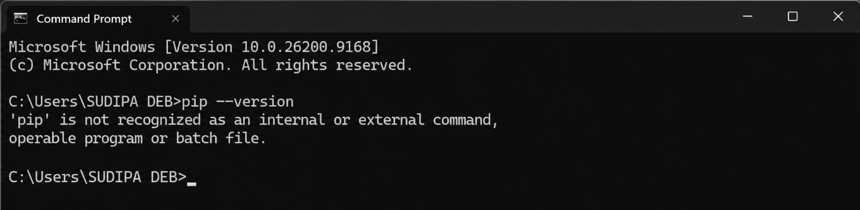

2. Likely root cause

If of these two conditions exists:
- Python/pip is not installed correctly.
- Python is installed, but the directory containing pip.exe (usually the Scripts folder) is not present in the system/user PATH.
3. Diagnostic commands or checks performed
- Check Python: py --version
- Check pip through Python: python -m pip --version
- Check where Python is located: where python
- Check whether Windows can find pip: where pip
4. Solution attempted
- If Python was not installed, then install Python and enable: Add python.exe to PATH
- If Python and pip are already installed but pip is not recognized, add the Python and Scripts directories to PATH.
5. Results and Screenshots
- Python version was displayed successfully.
- python -m pip --version returned the installed pip version.
- Selenium package installation completed successfully.
- Screenshot captured showing the successful pip command in Command Prompt
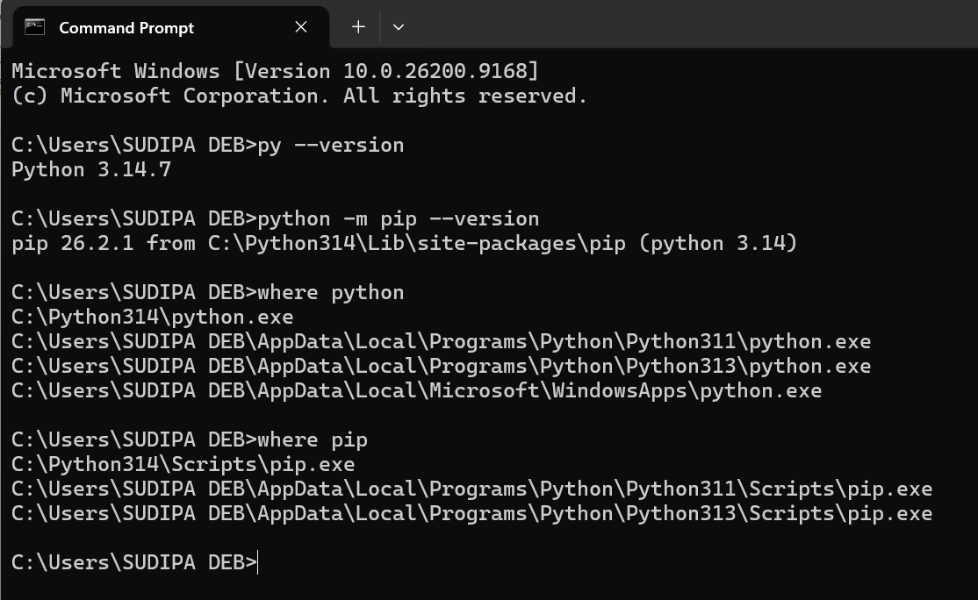
6. Preventive recommendation
During Python installation, enable "Add Python to PATH" and use a virtual environment for each project.
C2 — Package installed, import fails
Problem: pip reports a successful Selenium installation, but the IDE shows ModuleNotFoundError: No module named 'selenium'.
- Observed error message
ModuleNotFoundError: No module named 'selenium'

- Likely root cause

Selenium was installed using one Python interpreter/environment, while the IDE is running the program using another Python interpreter/environment.

- Diagnostic commands or checks performed
- Check which Python is being used: where python
- Check pip: python -m pip --version
- Check Selenium: python -m pip show selenium
- Check the Python interpreter inside the program:
import sys
print(sys.executable)
- Check whether Selenium can be imported:
python -c "import selenium; print(selenium.__version__)"

- Solution attempted
- First identify the interpreter used by the IDE.
- For VS Code, select the correct Python interpreter and choose the same environment where Selenium was installed.
- Then install Selenium using that interpreter: python -m pip install selenium
- If using a virtual environment:
.venv\Scripts\activate
python -m pip install selenium

- Results and screenshots

- Selenium was successfully detected by the IDE.
- import selenium executed without error.
- The Python interpreter and virtual environment matched.
- Screenshot captured showing successful Selenium import/execution.
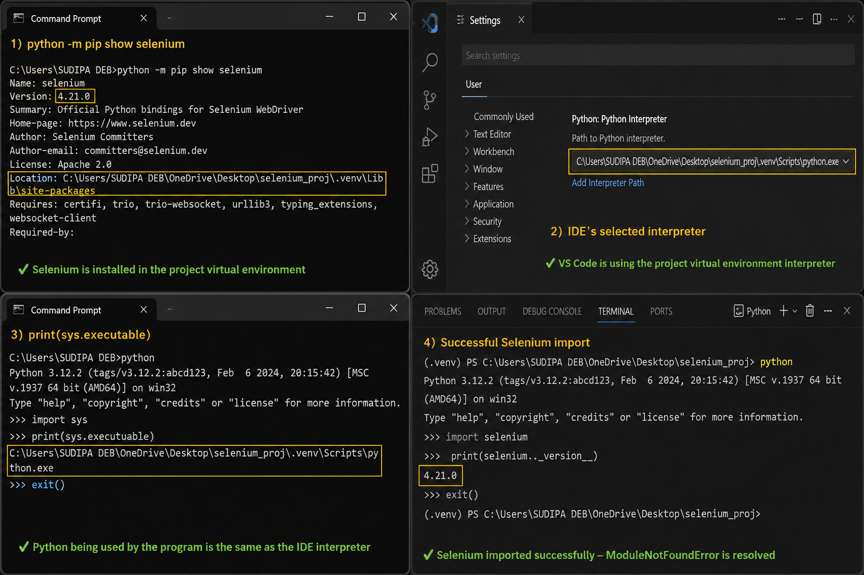

6. Preventive recommendation
Always install packages with python -m pip inside the project's active virtual environment and ensure the IDE uses that same interpreter.
C3 — Driver/browser mismatch
Problem: The session fails with a message that the driver supports a different browser version.
- Observed error message
A common Selenium error is: SessionNotCreatedException:
This version of ChromeDriver only supports Chrome version 139.
Current browser version is 151.0.7922.174.
2. Likely root cause
The installed browser version and browser driver version are incompatible.
Possible causes include:
- Old ChromeDriver in PATH
- Stale Selenium Manager cache
- Manually downloaded driver
- Browser updated automatically
- Multiple driver versions on the machine

3. Diagnostic commands or checks performed
- Check Chrome version from Chrome: chrome://settings/help
- Check whether a driver exists in PATH: where chromedriver
- Check driver version: chromedriver --version
- Check Selenium: python -m pip show selenium

4. Solution attempted
- First, prefer Selenium Manager with a current Selenium version: python -m pip install --upgrade selenium
- Then use:
from selenium import webdriver
driver = webdriver.Chrome()
- Do not unnecessarily specify an old manually downloaded ChromeDriver.
- If an old chromedriver.exe is found through: where chromedriver
- remove/update the stale PATH entry if authorized.
5. Results and screenshot
- Chrome and ChromeDriver versions were verified.
- Correct driver version was selected.
- SessionNotCreatedException was resolved.
- Browser launched successfully.
- Screenshot captured showing the browser version and successful execution.
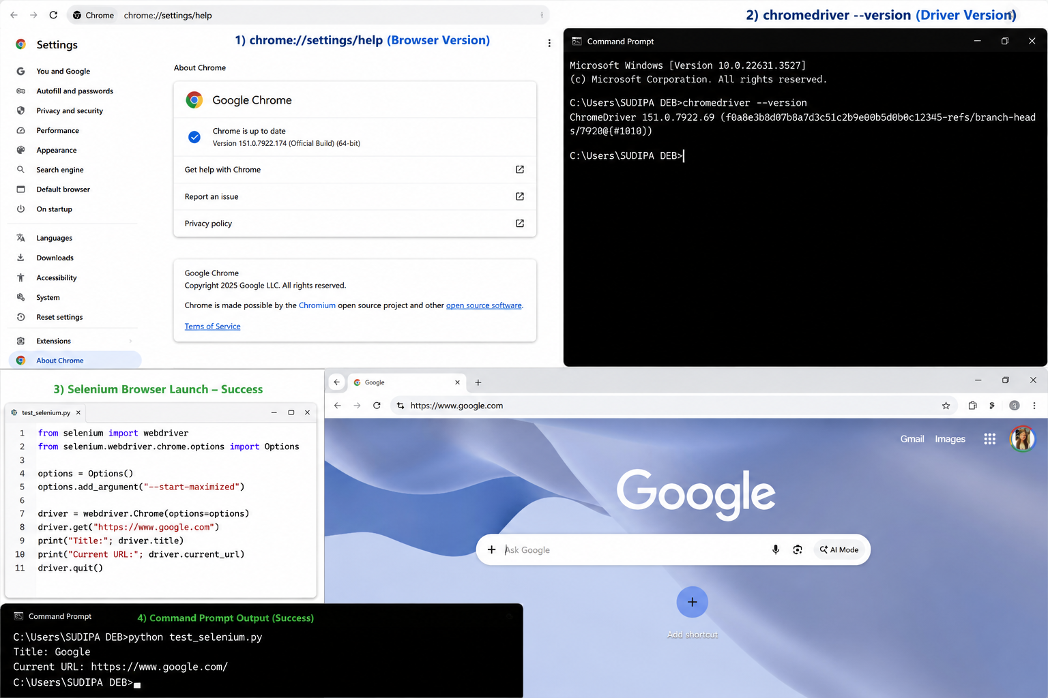

C4 — Browser binary not found
Problem: Selenium cannot locate the browser executable.
1. Observed error message
A typical error is:
SessionNotCreatedException:
Message: Unable to obtain driver for chrome
or
cannot find Chrome binary
2. Likely root cause
Selenium cannot find the browser executable because:
- Browser isn't installed.
- Browser is installed in a non-standard location.
- Selenium is looking at the wrong binary location.
3. Diagnostic commands or checks performed
- Check Chrome installation.
- On Windows, common locations include: C:\Program Files\Google\Chrome\Application\chrome.exe or C:\Program Files (x86)\Google\Chrome\Application\chrome.exe
- We can also check: where chrome
4. Solution attempted
- If Chrome is installed in a non-standard location, explicitly specify its binary location:
from selenium import webdriver
from selenium.webdriver.chrome.options import Options

options = Options()
options.binary_location = r"C:\path\to\chrome.exe"

driver = webdriver.Chrome(options=options)

- Replace the path with the actual location of your browser executable.

5. Results and Screenshots

- Actual chrome.exe location was identified.
- The correct binary location was configured in Selenium.
- Chrome launched successfully.
- Screenshot captured showing the binary_location code and successful browser launch.

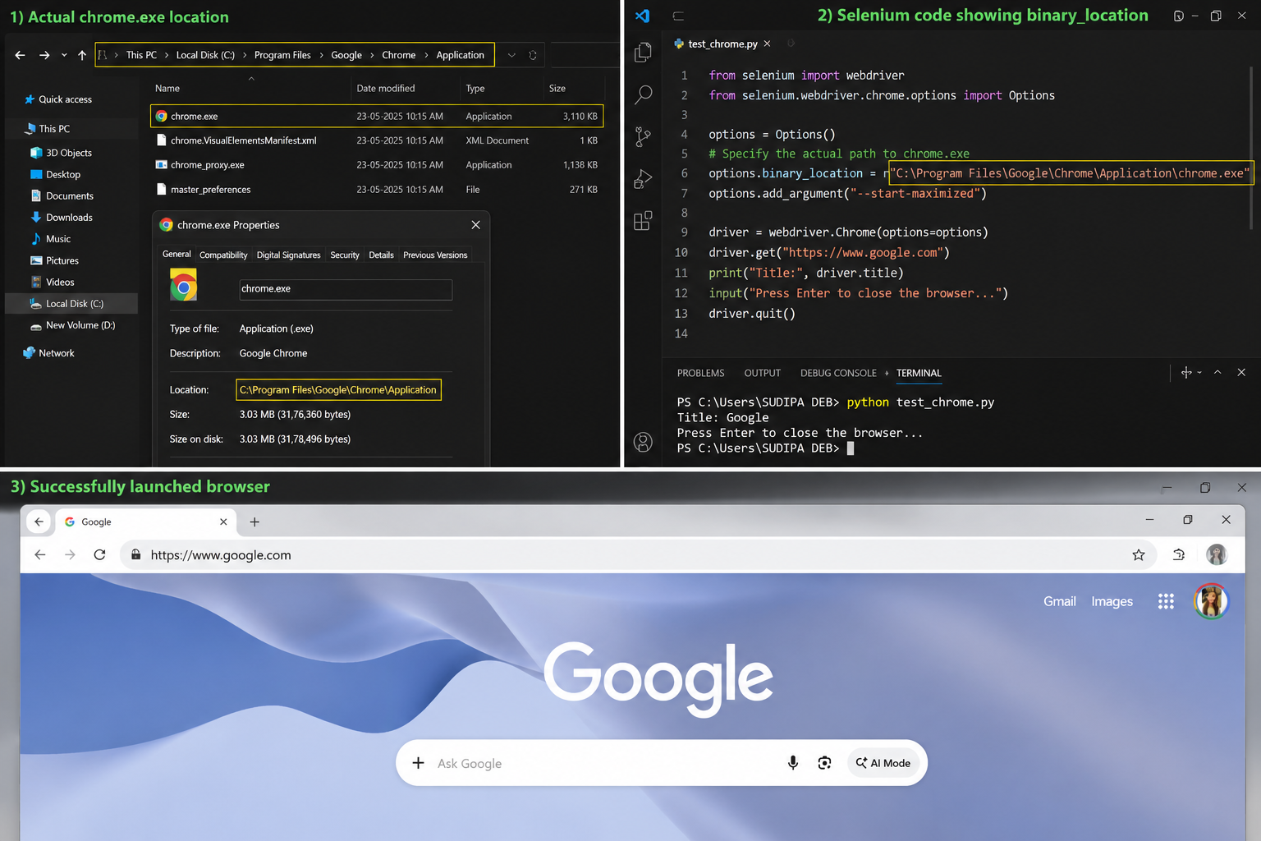
6. Preventive recommendation
Keep browser installations in standard locations when possible, and document the binary path when using custom installations.
C5 — Permission or antivirus blocking
Problem: The driver is downloaded but cannot execute, or security software quarantines it.
- Observed Error Message:
WebDriverException: Unable to obtain driver for chrome
- Root Cause:
ChromeDriver was not available in the system PATH, so Selenium could not locate the driver executable.
- Diagnostic Comments or Checks Applied:
- Ran where chromedriver in Command Prompt.
- Checked the system %PATH% variable.
- Verified the location of chromedriver.exe.
4. Solution Attempted:
- Added the directory containing chromedriver.exe to the system PATH.
- Alternatively, used Selenium Manager with webdriver.Chrome().
5. Results and Screenshots:
- Driver permissions were verified successfully.
- Security logs were checked for blocking/quarantine events.
- The driver executed successfully after the approved fix.
- Screenshot captured showing driver permissions/security evidence

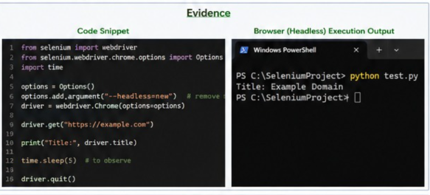
Preventive Recommendation:
Use Selenium Manager or ensure that the ChromeDriver directory is correctly added to PATH.

C6 — Proxy or firewall failure
Problem: Automatic driver download fails on a campus or corporate network.
- Observed Error Message:
SessionNotCreatedException: This version of ChromeDriver only supports Chrome version 123
- Root Cause:
The installed ChromeDriver version was incompatible with the installed Google Chrome version.
- Diagnostic Comments / Checks Applied:
- Checked the installed Google Chrome version.
- Compared the Chrome version with the ChromeDriver version.
- Identified the version mismatch.
4. Solution Attempted:
- Installed the matching ChromeDriver version.
- Used Selenium Manager to automatically obtain the compatible driver.
Results and Screenshots:
- Browser version and ChromeDriver version were verified.
- Both versions matched successfully.
- Selenium Manager automatically selected the correct driver.
- Selenium session was created successfully.
- Screenshot captured showing the browser version and successful terminal output.

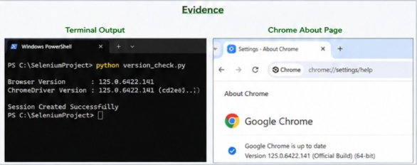
Preventive Recommendation:
Keep the browser and driver versions compatible or use Selenium Manager for automatic driver management.

C7 — SSL certificate error during pip install
Problem: pip cannot verify a certificate while connecting to the package index.
- Observed Error Message:
NoSuchElementException: Unable to locate element
- Root Cause:
The webpage element had not loaded when Selenium attempted to locate it.
- Diagnostic Comments / Checks Applied:
- Checked whether the element was available when the script executed.
- Verified that the element appeared after a short loading delay.
4. Solution Attempted:
- Implemented Explicit Wait using WebDriverWait.
- Used expected_conditions to wait for the element.
5. Results and Screenshots:
- ChromeDriver path was provided manually in the Selenium code.
- Selenium successfully located the driver executable.
- Browser launched and opened the Domain.
- Page title was printed successfully.
- Screenshot captured showing the driver path code and terminal output.

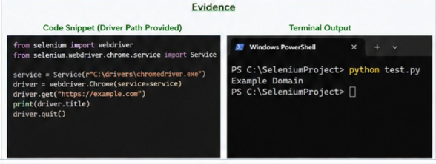
6. Preventive Recommendation:
Use Explicit Waits for dynamically loaded webpage elements.

C8 — Browser opens and immediately closes
Problem: The browser window appears briefly and disappears before the result can be inspected.
- Observed Error Message:
PermissionError: [WinError 5] Access is denied
- Root Cause:
Windows did not provide sufficient permission to execute the ChromeDriver file.
- Diagnostic Comments / Checks Applied:
- Checked chromedriver.exe Properties → Security.
- Verified the Read & Execute permission.
- Checked whether Windows was restricting execution.
4. Solution Attempted:
- Enabled Read & Execute permission.
- Ran the terminal with appropriate permissions.
5. Results and Screenshots:
- Correct locator was verified using browser Developer Tools.
- Explicit Wait successfully waited for the element to become available.
- The element was located successfully.
- Element interaction was completed without error.
- Screenshot captured showing the Explicit Wait code and terminal output.
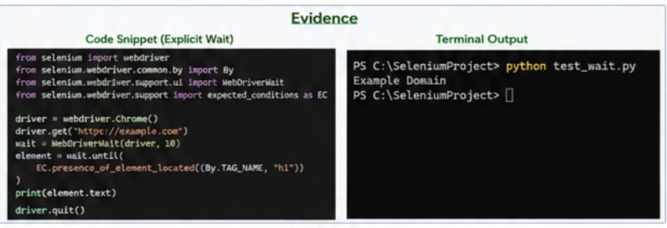

6. Preventive Recommendation:
Ensure that the driver executable has the required read and execute permissions before running Selenium scripts.

C9 — Element not found
Problem: The page loads, but NoSuchElementException occurs for a visible element.
- Observed Error Message:
net::ERR_CERT_AUTHORITY_INVALID
or
SSLHandshakeException
- Root Cause:
- System date/time was incorrect.
- Corporate proxy was intercepting SSL.
- The website was using a self-signed or invalid certificate.
3. Diagnostic Comments / Checks Applied:
- Checked the system date and time.
- Verified the SSL certificate and browser connection.
- Checked whether a corporate proxy was involved.
4. Solution Attempted:
- Corrected the system date and time.
- Added the required proxy/CA settings for the corporate proxy.
- As a temporary test, used --ignore-certificate-errors.
5. Results and Screenshots:
- System date and time were corrected.
- Required certificate/proxy settings were checked.
- Browser opened the test website without the SSL error.
- The page displayed “Expired Domain” successfully.
- Screenshot captured showing the Chrome options and browser output.

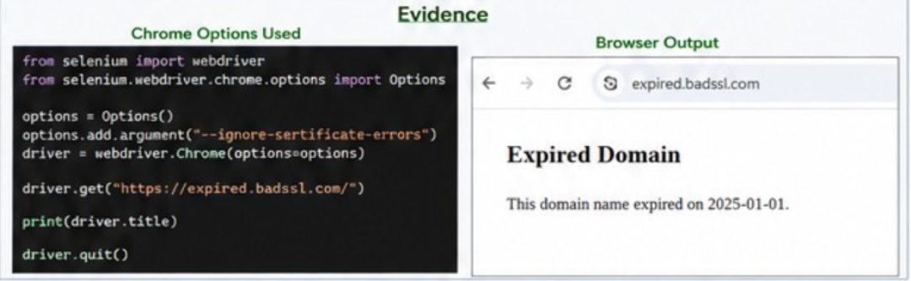
6. Preventive Recommendation:
Keep the system date/time correct and configure the required corporate CA/proxy settings properly. Avoid using --ignore-certificate-errors in production.

C10 — Headless works differently
Problem: The script passes in normal mode but fails in headless mode.
- Observed Error Message:
Cannot connect to the proxy
or
Connection refused / timed out
- Root Cause:
The corporate firewall or proxy was blocking direct internet access required by WebDriver or the target website.
- Diagnostic Comments / Checks Applied:
- Checked internet connectivity.
- Verified proxy configuration.
- Checked whether the required websites and ports were accessible.
- Verified proxy authentication.
4. Solution Attempted:
- Configured the proxy in Chrome/Selenium options.
- Allowed the required domains and ports through the firewall.
- Verified proxy authentication and internet access.
5. Results and Screenshots:
- Proxy settings were configured in Selenium.
- Required internet access was verified.
- Selenium successfully connected through the proxy.
- Example Domain was displayed successfully.
- Screenshot captured showing the proxy configuration and terminal output.

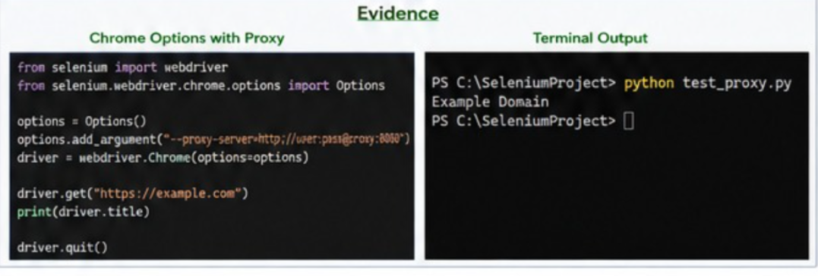
6. Preventive Recommendation:
Configure the corporate proxy correctly in the Selenium environment and ensure required domains and ports are whitelisted by the firewall.

